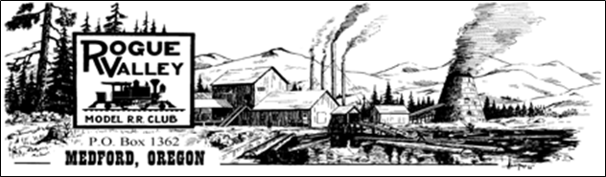

The Passing Track

January 15, 2020

We have reached the year 2020 and hopefully we are all healthy and looking forward to a great interactive and successful year ahead at the Medford Railroad Park.

As some of you may know, our 42nd Rogue Valley Railroad Show was a success. I have attached a copy of the letter from the Treasurer Bruce McGarvey for your information.

December 13, 2019

Medford Garden Railroad Club

Rogue Valley Model Railroad Club

Southern Oregon Live Steamers

Southern Oregon Railway Historical Society

The 42 nd Annual Rogue Valley Railroad Show is now history. A lot of

smiling faces were evident as we completed our fourth year at the Jackson

County EXPO. A big THANKS to all of you and your members for your great

exhibits and support.

We had a good weekend with some 3,600+ visitors. Your committee is still

fine tuning some of the logistics at the EXPO. I hope you saw the banner at

the Peninger Road entry to the fairgrounds which took a beating with the

Tuesday wind storm. Hopefully it’s repairable.

We had thirty seven vendors with 132 tables. Twenty exhibitors were

present of which three were new exhibits. Many comments were positive

on our new location.

Looking to next year, a show reserve at $7,000 is retained to meet

expenses prior to opening our doors on the Saturday show day.

Nevertheless, all bills are paid including next year’s deposits for the EXPO

and the Central Avenue street banner.

The net profit amounts to $5,417.81.

Work job hours were filled equally by each club, therefore the income has

been allocated one quarter to each. Each club check has been drawn at

$1,355 each and enclosed.

The current show committee welcomes new members. Critical positions

needed are: a work-job coordinator, a person to seek show sponsors and

someone to help plan and lay out the floor plan. Your input and support

are appreciated. Any suggestions should be given to your club’s

representative.

We wish you and your crew a happy and prosperous New Year!

Your Railroad Show Committee.

We had our first Committee meeting for the 43rd Annual Rogue Valley Railroad Show on January 15, 2020 at 3:00 pm at the clubhouse. We have new ideas for this upcoming show and we hope that some more of you would like to volunteer in helping plan for the show.

Talking about the show, brings to mind, that we need to revisit how we have coverage of the layouts during the show. My suggestion is that we have a sign up for the job duties for the Railroad Show, the layout and coverage of sales table. It is important that we have trains running on the layout during the show and need more than just one person doing so. Meeting the needs of our paying visitors to help with funds for our upcoming run days is very important. This year, we had some wonderful vendors with fantastic deals. We may have been a little lacking in layout coverage. Any ideas are welcome on how we can address this would be greatly appreciated.

We are also encouraging you to make a diarama to show next year. Can be any scale size, whatever scenery that you would like, but must have at least on set of train tracks. We want to show people that they can start off with a small area and expand into our wonderful hobby. I look forward to seeing what you all can come up with. Plans are that we get our visitors at the show to participate in future years to win a ribbon. I will supply you with the dimensions etc after our next Show Committee meeting in February.

On December 21st, 2019 we had a fun day with our monthly OP Session and Christmas Potluck. I must say it was a great turn out. Lots of participation from all our club members. People got to run different areas that they normally do not do. We had some new members that got the chance to see how it operates and participate. It was a fun day filled with trains, friends, memories, great food and discussions of our favorite hobby. I have attached a link to the photos that I took for your enjoyment.

<https://photos.app.goo.gl/CNY23U3Rovtfv3nPA>

Thank you to all of you that came and helped with food, entertainment, and all.

This year we are going to start working on insulation and shelving in our 2nd shed. This houses our show committee stuff, signs for parking, donations to our club, etc. The plan is to have the shelving fit the same size boxes (apple boxes) to make it consistent. We need electrical wiring, insulation, drywall, and shelving attached. Those of you that have electrical skills, and carpentry skills are most welcome. We will also need muscle to move what is currently in the shed into our clubhouse during renovation.

Also, during the year, we are in need of volunteers to update the scenery on the modules and the layout. As well as working on the cars that are run on the layout during run days and OP Session. Checking on couplers and wheels, etc. We have a set few that this has fallen on, but fresh ideas and input are greatly appreciated and needed. I would like to suggest that we set up day and times that we pick areas to focus on. Maybe even on a monthly basis. I would love to see some fresh input on our modules that we take to the yearly show.

Do you have any input for the passing track? Have ideas for the upcoming year? Please send me a message or come to our monthly meetings. The 3rd Tuesdays of the month at 7:00 PM at the club house is our monthly meetings.

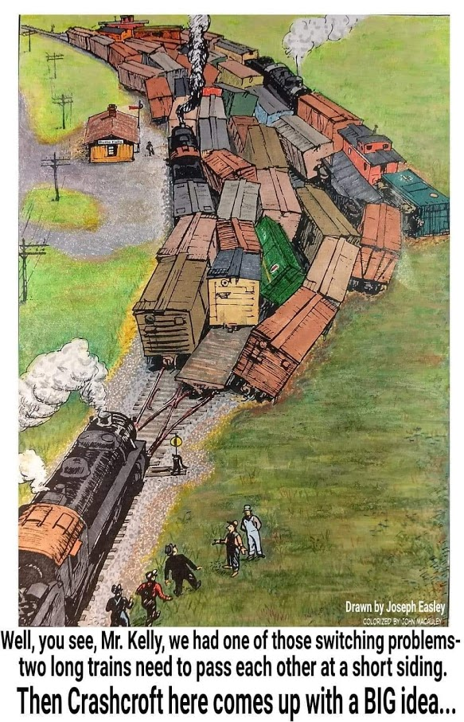 submitted byJohn Macauley

Make sure you check out the new scenery on the layouts that have been added by Paul and Dave Hendrickson

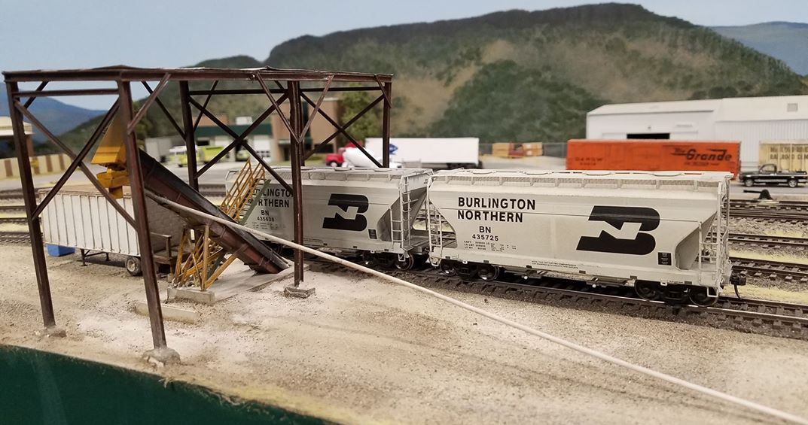

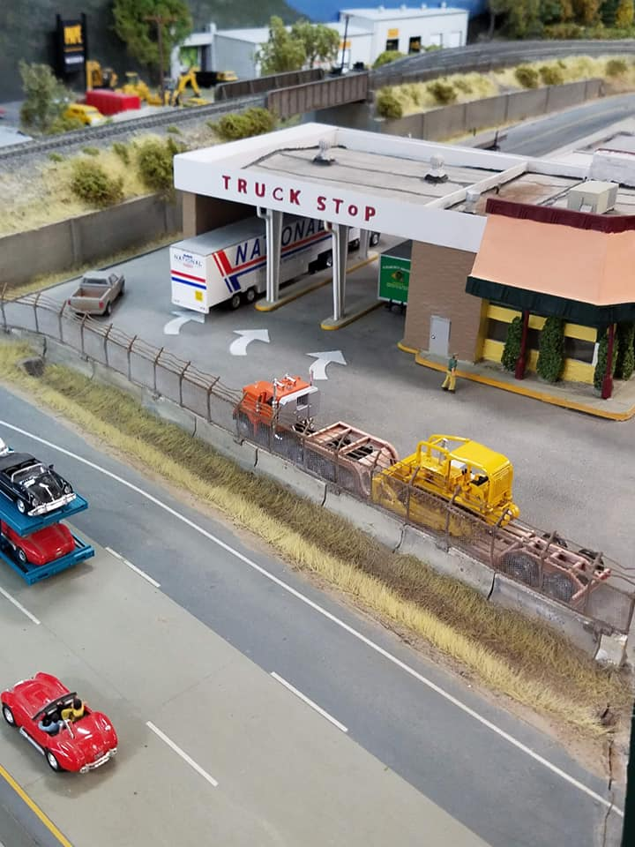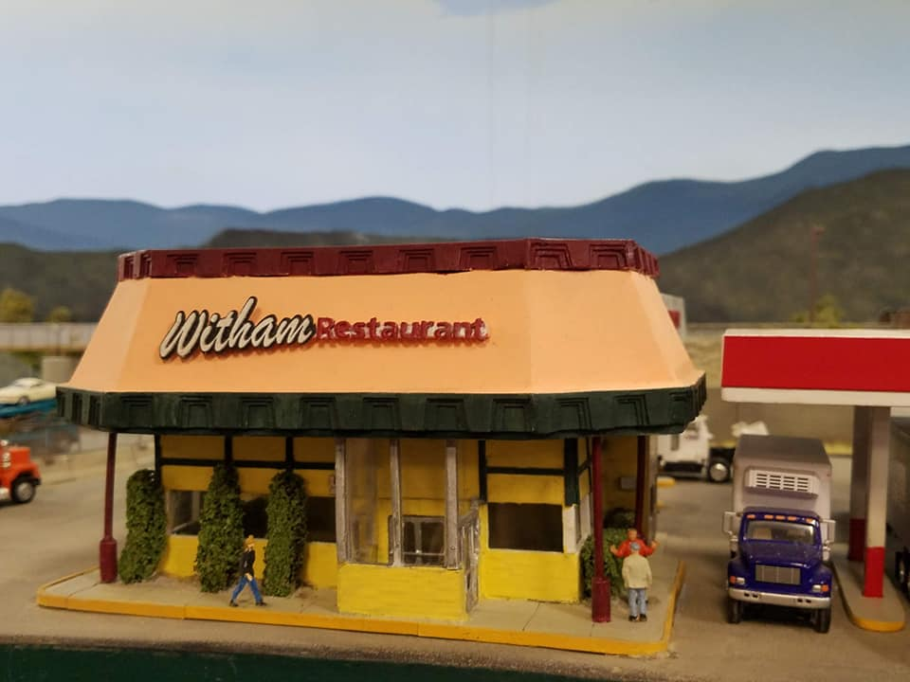

Timetable

**Sat. Feb 8th 2020 9am-3pm**

7th Annual Northwest Modelers Train Show & Swap Meet

Rickreall Grange Hall

280 Main Street, Rickreall, Oregon 97371

**Feb 22-23, Monroe, WA**

United NorthWest Model railroad Club and Snohomish County 4-H Foundation Present: 29th Annual Washington State Model Railroad Show and Marketplace Evergreen State Fairgrounds, Monroe WA Saturday 10am - 5pm, Sunday 10am - 4pm Operating Model Railroads, Clinics, Demonstrations, Swap Meet tables, Food vendors, and more! Proceeds benefit Snohomish County 4-H Foundation [www.facebook.com/unwclub](http://www.facebook.com/unwclub) [www.unwclub.com/unwshow.htm](http://www.unwclub.com/unwshow.html)

**Mar 7-8, Spokane, WA**

River City Modelers open house, 1130 E. Sprague Ave., Spokane, WA 99202. Visit the River City Western HO scale model train layout. The 45 x 40 ft. two-level layout is a work in progress. Much of the scenery is completed, track work is mainly done and details are being worked on. There are approximately 19 scale miles of main line track. Open from 4 to 8 PM on Saturday and Noon to 4 PM on Sunday. Contact 509-535-3462 for more information.

**Mar 8 (Sun), Spokane, WA**

The SPOKANE TRAIN SHOW - Sponsored by the River City Modelers, 9:30 AM until 3:30 PM at the SPOKANE County Fair & Expo Center, Ag A, B, & C Buildings, 404 N. Havana St. $6.00 ADMISSION- 12 & UNDER FREE. Over 200 tables of railroad related items for sale - model & toy trains, photographs, books, toy autos & trucks, bridges & buildings. Train memorabilia - old lanterns. signs, china, linen, switch locks & keys & more. There will be several operating train layouts in N, HO, S, and G Scales. There will be a LEGO train layout, very large Free-MO HO layout and Operation Lifesaver will be there too. Back again at this show will be the WTrak wooden layout for kids to play with. Free parking! FOR TABLE RENTAL OR GENERAL INFORMATION - CONTACT: SHIRLEY SAMPLE, P.O. Box 3065, Spokane, WA 99220; call 509-991-2317, 509-292-8332 OR EMAIL: shirley@busnws.com

**Mar 14 (Sat), Portland, OR**

WIllamette Model Railroad Club Swap Meet 9:30 am to 3 pm at the W.D. Jackson Armory 6255 NE Cornfoot Rd. Portland, OR 97218. Over 115 tables of Model Railroad equipment in all Scales, Railroad Memorabilia, Books, Photos and More. Admission $5.00, under 12 free. Free parking. Info: Brigg Franklin wmrcswapmeet@gmail.com (360) 241-5908.

**Mar 21 (Sat), Boise, ID**

3rd Division NMRA Spring Meet, Shepherd of the Valley Lutheran Church, 3100 S. Five Mile Rd., Boise, ID 83709 (Victory and Five Mile) Registration - 8:30 amInfo:- Chris Mesa [cmesa57@gmail.com](mailto:cmesa57@gmail.com)

**Apr 21-24, Eugene, OR**

First Division will host the NMRA Pacific Northwest Region Annual Convention at the Valley River Inn. Info:- [pnr.nmra.org/1div/Eugene2020/home.htm](http://pnr.nmra.org/1div/Eugene2020/home.htm)

**Apr 25-26, Eugene, OR**

31St Annual Willamette Cascade Model Railroad Club Swap Meet & Train Show, Lane Events Center at 796W. 13th Ave. One of the largest swap meets on the West Coast featuring 22,500 square feet of trains in all scales, books, memorabilia, and historical societies in attendance. Hourly door prizes for the public, Operation Lifesaver Trailer with educational safety around railroads for pedestrians and vehicles. Vendors from 9 different states and over 250 tables of merchandise for sale. Early bird special (Sat. only) get in at 9:00 a.m. for $10 per person, regular admission is $6.00 per person adult through 12 years of age, 11 years to 6 years old $1.00 per person, kids 5 years and younger are free if accompanied by an adult. Admission is good for both days. For more information contact 541-954-4917 or email at ttandt@ram-mail.com Vendor Registrations forms are available on our website at [www.wcmrrc.org](http://www.wcmrrc.org/). or follow us on Facebook.com/wcmrrc.

**May 2 (Sat), Portland, OR**

Portland's 3rd Annual Railroad Prototype Modelers Meet. Portland Airport Shilo Inn, 11707 NE Airport Way, Portland, OR 97220 9AM to 5PM We encourage railroad modelers (model railroaders) to bring their creations (completed or in progress) to share with others. This is intended to be a get together to bring modelers together, share & discuss techniques, talk prototypes and inspire others with their models. We will also be having CLINICS throughout the day and a LARGE RAFFLE! Info:- [www.brpmm.com](http://www.brpmm.com/)

I am sure that I may have missed some, but wanted to get this out without further delay.

Have a great rest of your month.

Kimberly Jamin

541-841-8317